SESSION 7
READING CANDLE STICK CHARTS
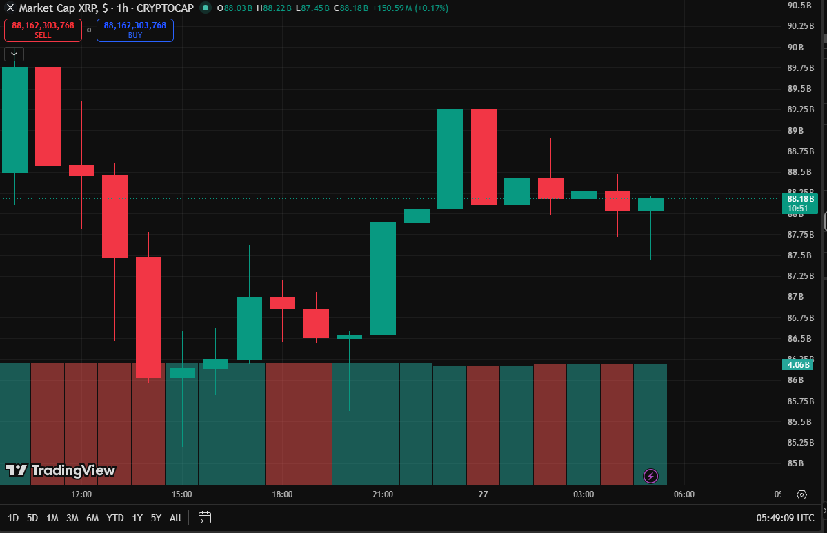

CANDLESTICK OBSERVATION TABLE
PARTICULARS | OBSERVATION
ASSET | XRP
SYMBOL | XRPUSD
Time Frame | 1 Hour(1hr)
Number of Green Candles Observed | 11
Number of Red Candles Obsrved | 9
Doji Observed | Not Observed
Hammer Observed | Not Observed
Shooting Star Observed | Not Observed

SESSION 8

Observing Price Direction

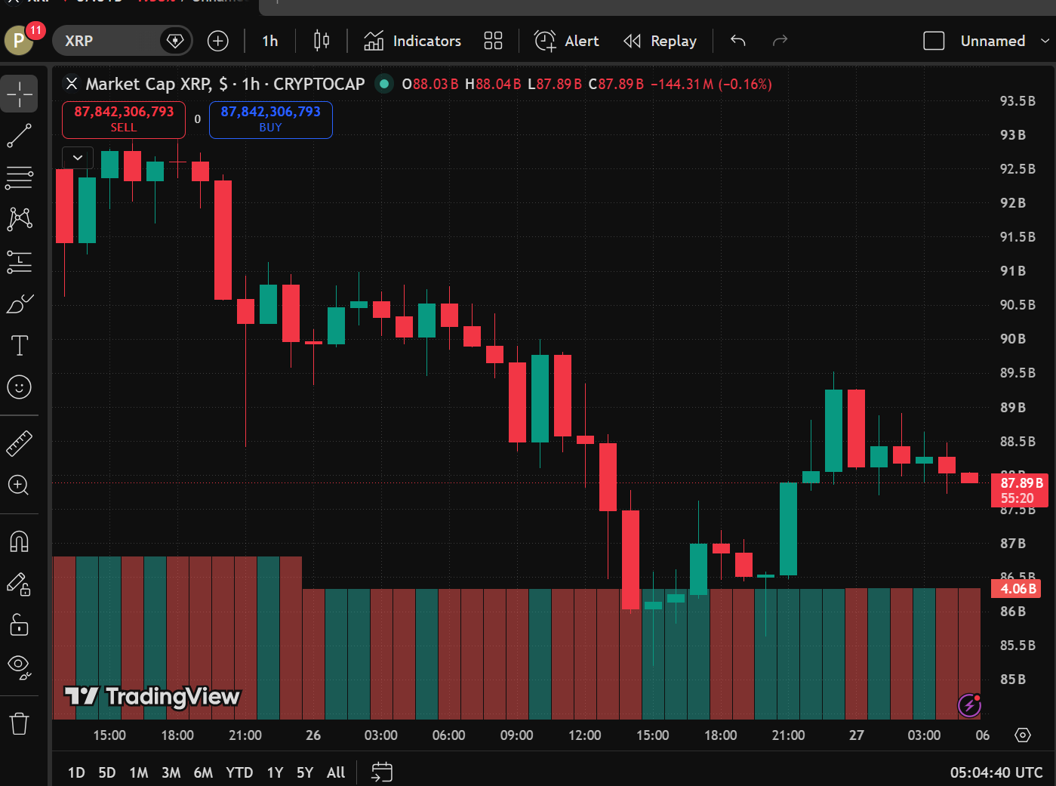

Trend Observation

PARTICULARS | OBSERVATION
ASSET NAME | XRP
TIME FRAME | 1 HOUR
TIME OBSERVED | DOWNTREND
NUMBER OF CANDLESSTICKS OBSERVED | 40
REASON FOR IDENTIFING THE TREND | THE CHART SHOWS A SERIES OF LOWER HIGHS AND LOWER LOWS  AND IT INDICATES THE DOWN TREND

SESSION 9
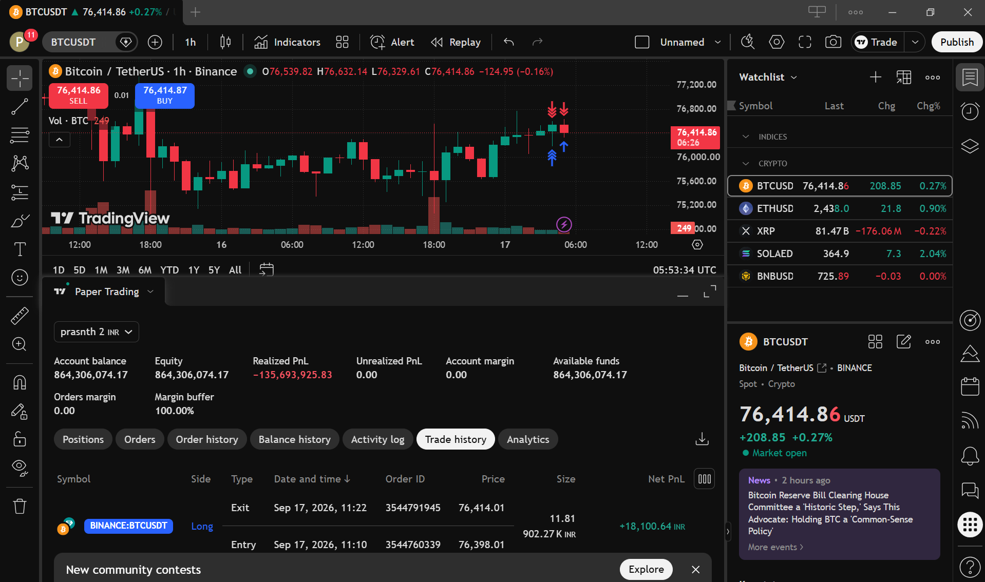

Trend-Based Trade Report.

Particular | Observation
Asset Name | BITCOIN
Symbol | BTCUSDT
Timeframe | 1 Hour (1H)
Trend Observed | UP TREND
Trade Type | Long (buy)
Entry Price | 76398.01
Exit Price | 76414.01
Realized Profit/Loss | +18,100.64
Trade Outcome | PROFIT
Reason for Identifying the Trend | The price is forming higher highs and higher lows, indicating strong buying pressure and a short-term bullish trend.

